FOR IMMEDIATE RELEASE

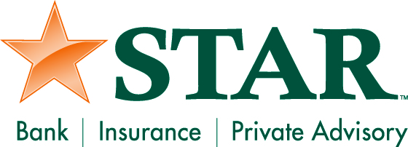

Contact: Kristin Marcuccilli
SVP, Chief Operating Officer
Phone: (260) 479-2622

STAR Bank Promotes Cyber Security Awareness with Tips for Protecting Mobile Devices
October is National Cyber Security Awareness Month

FORT WAYNE – The number of attacks on mobile devices is growing, in part, as a result of the increased popularity of mobile banking. According to a 2013 report by the Federal Reserve, 87 percent of the U.S. population has a mobile phone and 52 percent have smart phones. Of those mobile phone users, 28 percent have performed banking transaction in the past 12 months.
“The rise in the popularity of mobile devices has certainly made them a target for cyber-criminals. The types of attacks we’re seeing have generally been used on PCs but are now making their way to other devices,” said Michael Krouse, Information Security Officer for STAR Bank. “We work hard to protect customer information and customers play an important role. Any device used to connect to the Internet is at risk and we urge users to keep safety measures in place.”
In recognition of National Cyber Security Awareness Month, STAR Bank recommends that consumers take extra precaution to protect the data on their mobile device by doing the following:
- Use the passcode lock on your smartphone and other devices. This will make it more difficult for thieves to access your information if your device is lost or stolen.
- Log out completely when you finish a mobile banking session.
- Protect your phone from viruses and malicious software, or malware, just like you do for your computer by installing mobile security software.
- Use caution when downloading apps. Apps can contain malicious software, worms, and viruses. Beware of apps that ask for unnecessary “permissions.”
- Download the updates for your phone and mobile apps.
- Avoid storing sensitive information like passwords or a social security number on your mobile device.
- Tell your financial institution immediately if you change your phone number or lose your mobile device.
- Be aware of shoulder surfers. The most basic form of information theft is observation. Be aware of your surroundings, especially when you’re punching in sensitive information.
- Wipe your mobile device before you donate, sell or trade it using specialized software or using the manufacturer’s recommended technique. Some software allows you to wipe your device remotely if it is lost or stolen.
- Report any suspected fraud to your bank immediately.

###

Note: In all references to STAR, “STAR” should be in all caps.

STAR Financial Bank, headquartered in Fort Wayne, Indiana, is committed to delivering quality financial expertise and distinctive banking solutions to exceed customer needs. In addition, STAR Private Advisory offers private banking, investment and fiduciary services. STAR Insurance Agency is a full service insurance and annuity provider. STAR has grown to $1.6 billion in assets with 54 locations in central and northeast Indiana. For more information, visit the company’s web site at starfinancial.com.

