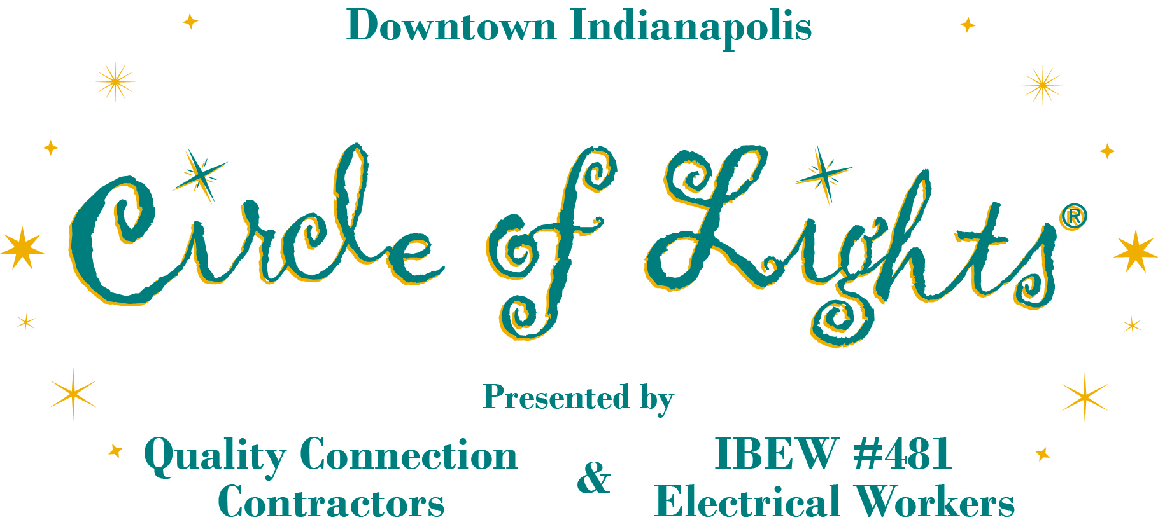

MEDIA ADVISORY/PHOTO OP

Monument Circle transformation to Circle of Lights®

gets underway Saturday, Nov. 9 in preparation for Downtown holiday season

IBEW #481 union electricians ready to string the 4,784 lights & garland strands for the 51st year

WHAT: Approximately 200 volunteer union electricians will gather alongside dozens of electrical contractors on Monument Circle this Saturday to string the 4,784 lights and 52 garland strands, which will become the centerpiece of 51st Annual Circle of Lights® presented by the Contractors of Quality Connection and Electrical Workers of IBEW #481.

WHEN: Saturday, Nov. 9, 8:45 – 11 a.m. (Best photo opportunity)

WHERE: Indiana Soldiers & Sailors Monument

WHO: Sean Seyferth – IBEW #481 Business Manager, representing more than 3,000 International Brotherhood of Electrical Workers (IBEW) #481

Julia Saltsgaver – Executive Director of Quality Connection, representing 100 union electrical contractors

Bob Schultz – Vice President of Indianapolis Downtown, Inc., representing the homes, attractions, businesses and organizations of Downtown Indy

200 volunteers – union electricians and electrical contractors working with more than six miles of electrical wire, more than two miles of garland

CONTACT: Jennifer Hanson, Indianapolis Downtown, Inc., 237.2202 (Nov. 9: 446.4106)

Installation History:
Seven mayors and nine governors have served our city and state over the past 51 years. However, only one organization has taken part each year in this holiday event since 1962. The IBEW #481 union electricians have always been the group on the ground to install and remove the decor. IBEW #481 was first the labor crew for the electrical contractor who managed the initial development and then became the labor leader that maintains, stores, installs and removes the decor annually. In 2004, IBEW #481 and its labor-management partnership, The Quality Connection, expanded its role to become the presenting partners of Circle of Lights® presented by the Contractors of Quality Connection and Electrical Workers of IBEW #481.

Event Background:
Circle of Lights® presented by the Contractors of Quality Connection and Electrical Workers of IBEW #481 will take place Friday evening, Nov. 29 on Monument Circle. More than 100,000 holiday enthusiasts are expected to attend Indiana’s largest, annual, FREE public gathering now in its 51st year. The event will include special appearances from holiday entertainers including Indianapolis native Sandi Patty, as well as The von Trapp Family singers, both appearing at the Indianapolis Symphony Orchestra’s Duke Energy Yuletide Celebration, and the larger-than-life toy soldiers and sailors and peppermint sticks adorning Monument Circle. In addition, central Indiana entertainers selected from state wide auditions will perform and Santa will make his first official appearance of the 2013 season!

About Quality Connection and IBEW #481
As the presenting partners of Circle of Lights©, Quality Connection is a labor management partnership that represents more than 100 union electrical contractors and more than 3,000 International Brotherhood of Electrical Workers (IBEW) #481 electrical workers. Together labor and management provide the needed expertise, highly trained workforce, safety and dedication to help build many of Central Indiana’s premiere education, life sciences, health care, utility sites and logistics projects. The unique business relationship spans more than 50 years and represents a strong tradition of quality electrical construction, progressive labor negotiations and community service. With an unprecedented commitment to workforce training, job safety and worker standards, Quality Connection… Quality Work, Customer Connected. Visit www.qc-indy.com

About Indianapolis Downtown, Inc.
Because central Indiana needs a strong and vibrant core, Indianapolis Downtown, Inc. exists to continually improve Downtown Indianapolis. IDI is action-oriented and empowered to address, in partnership with the public and private sectors, critical issues that affect the growth, well-being and user-friendliness of Downtown. IDI focus on three areas: development, management and marketing. IDI is the organizing body behind Circle of Lights®.

-30-

