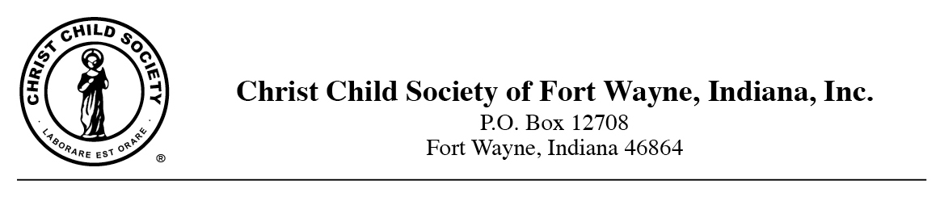
November 13, 2013 Contact: Katie Steigmeyer
FOR IMMEDIATE RELEASE Communications
kms0918@msn.com

Christ Child Society Annual Holiday Cookie Walk to Benefit Local Children

FORT WAYNE, Ind. – The Christ Child Society of Fort Wayne will be holding their annual Holiday Cookie Walk to benefit children in need in the Fort Wayne area. The Holiday Cookie Walk will be held on Saturday, December 7th from 8:30am to Noon at St. Vincent Catholic Church on Wallen Road. The Cookie Walk features a variety of delicious homemade cookies and baked goods for all tastes. All proceeds of the sale will be used to fund the programs of the Christ Child Society operating to improve the lives of local children in need.

-CCS-
The Christ Child Society of Fort Wayne is a non-profit organization of volunteers of many denominations devoted to serving the at-risk children of Fort Wayne regardless of race or creed. Our services include providing layettes to families in need at local hospitals, operating the Crib Club Rooms at the Women’s Care Centers in Fort Wayne, distributing Winter Coats through our Annual Coats for Kids program and providing backpacks to children in crisis situations through the Foster Care Family Association.

For more information, visit www.christchildfw.org.

